**Chatbot Using Python**

1. **DESCRIPTION**

Chatbot is a application which has a database, it has an app l and APIs to call the other external administrations. However, bots cannot comprehend about what the customer has planned. It is a very much common problem that must be tackled. Bots are generally trained according to the past information which is only available to them. So in most of the organizations, chatbot maintains their logs of discussions so that they can understand their customers behaviour.

Developers utilize these logs to analyse what clients are trying to ask. Developers coordinate their with their client inquiries and reply with the best appropriate answer with the blend of machine learning tools and models. Training a chatbot is very much faster and also on a large scale as compared to human beings. A customer support chatbot is filled with a very large number of conversation logs which help the chatbot to understand what kinds of questions should be asked and answers should be given. While a normal customer service representatives are given manual instructions which they have to go through with. The chatbots is based on three methods:

1. *Pattern Matches:* The pattern matches group of texts is utilized by the bots and it so it produces an appropriate response to the customers. The standard structured model used for creation of these patterns is “Artificial Intelligence Markup Language”.
2. *Natural Language Understanding (NLU):* Finding the way to convert the user’s speech or text into structured data is called Natural Language Processing. It is used to get relevant answers for the customers.

To develop a chatbot one must be very clear about what one wants from that chatbot. Often they are developed for business platforms like Net Banking sites to handle costumer Q&A. Another type of chatbot is widely developed and used are smart assistants like Google assistant, Siri , Alexa, Cortana etc.

1. **INTRODUCTION**

The improvements in the fields of inter-networking and information technology have been intricate in executing an Artificial Intelligent systems. These systems are drawing near to human activities for example choice emotionally supportive networks, robotics, natural language processing. Indeed, even in the artificial intelligent fields there are some hybrid strategies and adaptive techniques that make increase complex techniques. That, yet these days there are additionally several Natural Language Processing and intelligent systems that could comprehend human language. AI systems learn themselves and retrieve insight by perusing required electronic articles that have been exist on the web page.

A chatbot is an AI program that copy human discussions including content and communication in natural language utilizing artificial intelligence method for example, Natural Language Processing is a picture and video processing and voice analysis. chatbot for college management system has been created utilizing AI algorithms that examine the user queries. This chatbot system is an internet application that gives an answer to the broken down queries of a user. Users simply need to choose the classification for inquiries and afterward they can ask the question to the bot that utilizes for noting it. AI has been incorporated to respond to the users inquiries then the user can procure the fitting solutions to their inquiries.

Chatbot has become the centre of focus in this current era thus the bot are being utilized to deliver information more conveniently. A chatbot is a standout amongst the most progressive and promising tools of communication among people and machines. famous chatbots like amazon Alexa, Siri, Facebook, Slack, and many more are in trend. These are very much helpful but in this era of enhancing technology day by day, technology gets updated and accordingly by the user expectations also increases. A user wants more automation in the chatbot although every system is not perfect but there is always a flaw in the system. so in the chatbot there are some problems that the user has experienced while using a chatbot. A chatbot can be described as an answering system where a system will be able to answer questions or to the statement submitted by users and allow users to control over the content to be displayed

### LITERATURE SURVEY

According to the survey on Chatbot Implementation in Customer Service Industry through Deep Neural Network, the strategies for creating rules for chatbot have been advanced. strategy for creating chatbots has depended on hand-written rules and templates. With the rise of deep learning these models were quickly replaced by an end-to-end neural network. All the more specifically DNN is a powerful generative-based model to take care of the conversational response generation problems. This paper led an inside and out the review of ongoing literature, examining more than 70 publications related to chatbots published in the last 5 years. based on a literature survey this examination made a comparison from chosen papers according to the strategy adopted. This paper also introduced why current chatbot models fail to take into account while generating responses and how this affects the quality of conversation.

According to the research intent detection based Lithuanian chatbot created via Automatic DNN hyper-parameter

Optimization they handled a purpose recognition issue for the Lithuanian language with the real supervised data. The main principle of focus is on the upgrade of the NL

Understanding module, responsible for the comprehension of user questions. The NLU model is prepared with an appropriately selected word vectorization type and a Deep Neural Network classifier. During their experiment, they have tentatively investigated fast text and bert embeddings.

According to research chatbot technologies and challenges they gave an outline of the innovations that drive chatbot including Information Extraction and deep learning. they have additionally examined the contrasts between conversational and transactional chatbots. the former is defined manually on free form chat logs while the last is characterized physically to accomplish a particular objective like booking a flight. they have likewise given an outline of commercial tools and platforms that can help in creating and deploying chatbot. at last, they have introduced the limitations and future work difficulties around here.

According to research Accessible conversational user interfaces consideration for design scope of current guidance and flow direction, reports, exploration and writing on an open plan for various disability groups of incorporating clients with psychological well-being issues, mental imbalance, medical issue, intellectual incapacities, dyslexia, or learning challenges, and tangible, versatility or ability weaknesses. they grouped the component from this assortment of directions that seem applicable to the plan of available CUIs, and cases where direction presents issues that are less decisive, and require further investigation.

According to research Ensemble-based, deep reinforcement learning for chatbots trainable chatbots that show familiar and human-like discussions remain a major challenge in artificial intelligence. Deep Reinforcement Learning is promising for tending to this test, however, its fruitful application remains an open inquiry. This article portrays a novel ensemble-based methodology applied to esteem-based DRL chatbots which utilize limited activity sets as a type of importance portrayal. In their methodology, while exchange activities are obtained from sentence clustering, the training datasets in our ensemble are obtained from discourse clustering. they latter plan to induce specific agents that figure out how to communicate in a specific style.

### PROPOSED SYSTEM

This college chatbot system is a web-based application that gives responses to user queries. The system architecture of the chatbot system is shown in the first chatbot responds to the user by greeting him or her and then asks a user to login into the system by providing his or her mail. then the user finds the button in the UI which corresponds to the different categories of the college. after going through the buttons the chatbot system asks the user is it helpful or not with the response. If the user is not able to find the required response he or she can continue the chat with the college chatbot system by briefly elaborating their queries. Then chatbot system applies an ML algorithm to break down the user queries.

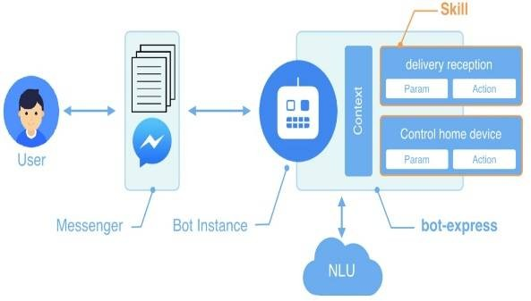

Fig 1 : Architecture Of Chatbot

1. *Login:* After clicking on the chatbot provided in the college website. the chatbots system greet the user and request the user to provide thier mail ID. After that chatbot start chatting with the user.
2. *Botindex:* When the user proceed to choose chatbots to get an answer to his or her query the chatbot display a page to select few options regarding college and identifies his or her category of query. If the user gets his query cleared and then the task of chatbot is completed.
3. *Asking Queries:* If the user is not satisfied with the rule-based response then the chatbot system request to enter his or her query in word and the suitable response is given by the chatbot. the user query is first checked in the database. if the query is valid then a suitable response is given to the user. If the query is invalid then the chatbot request user to ask queries regarding the college.
4. *Providing Feedback:* After the chat, the chatbot takes feedback from the user. feedback is taken in order to know the user's experience with the chatbot. if the user gives feedback positively then the bot thanks the user and provides a box to enter any further queries. if the user gives feedback negatively then the bot asks the user to elaborate his or her query in order to respond. username of the user is also stored and helps the admin to track user actions.

On the other end, the admin who is responsible for maintaining the college chatbot system up to date has several functions to perform such as adding the query to the database modifying the data, deleting the data, viewing feedback given by the user, and so on.

* 1. 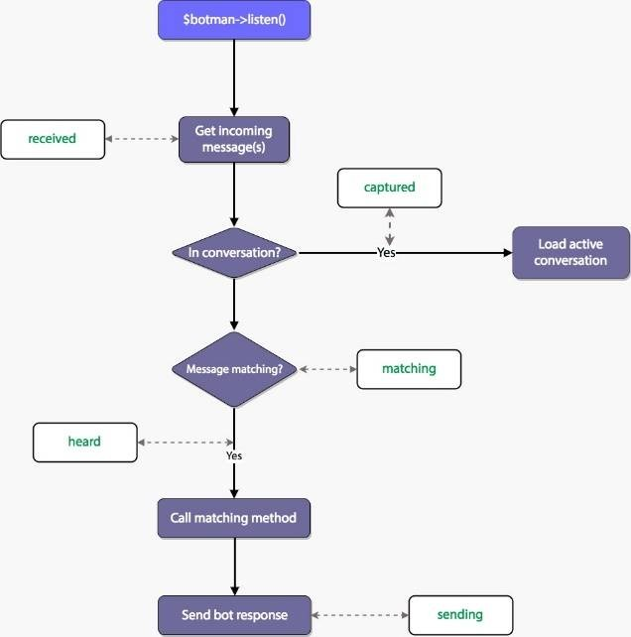*Login:* System has only one Admin has to login by providing his or her username and password entered password is encrypted using AHA-256 encryption algorithm. The login details are validated against the username and password which are stored in the database and are encrypted using the AHA-1 encryption algorithm. if the details provided are matching with the database then the admin can get access to the college chatbot system.

Fig 2 : Flowchart Of Chatbot

* 1. *Add Query:* If the admin proceeds to add the dataset then the chatbot allows to add the query in three option that is the addition of question addition of answer and selecting the respective category into which dataset is added.
  2. *View Dataset:* If the admin proceeds to view the dataset then the chatbot allows to view the dataset category-wise. The chatbot also gives an additional two options that delete the dataset and modify the dataset.
  3. *Delete Query:* If the admin proceeds to delete the query then the chatbot allows to delete the query from the view page itself by selecting the respective category.
  4. *Modify Query:* If the admin proceeds to modify the existing query then the chatbot allows to modify the query from the view page itself by selecting the respective category.
  5. *Change Password:* If the admin wants to change the password then the chatbot allows to change the password. to change the password admin must provide the old password and new password and then re-enter the new password in the change password webpage. thus creating a new password that is encrypted and stored in the code.
  6. *Viewing Invalid Dataset:* If admin proceeds to view invalid dataset then the chatbot allows to view the dataset category-wise. the invalid data is the data to which the user has given negative feedback or the queries for which the chatbot is unable to respond. the chatbot also gives an additional two options that are deleted and modify the corresponding query.
  7. *Edit Static Answers:* The text displayed when the user selects buttons in the GUI of the chatbot system can be updated or modified by the admin. the admin can update the information which is obtained by selecting the button in the webpage or can change the function of the button by rewriting in the database format.

### RESULT AND DISCUSSION

A Chatbot system is implemented to meet the requirements of the users. simulation / generating response from a chatbot is whenever the user context is matched. When a user begins asking queries in the chatbot GUI. the query is searched in the database. If the response is found in the database it is displayed to the user or else the system notifies the admin about the missing response in the database and gives a predefined response to the user.

Admin can write the missing response into the database by logging into the admin block on the website. the chatbot is based on AIML language which is a type of XML. this helps the different types of users to get information like university rank holders, timetables, latest news, updates regarding college exams and activities, and other academic information.

The result of our chatbot always varies as it is a natural language chatbot that gives us the same answer in many different ways. the chatbot always keeps learning as the number of users increases or decreases or uses it more. the accuracy of the chatbot also increases with the usage of the bot.

### CONCLUSION

In this project, we made a college-specific chatbot system that can be custom and fits in an education domain chatbot the addition of this chatbot system in the college website will make the webpage more user interactive as it responds to the user queries very accurately as it is a domain-specific chatbot system, and furthermore we had investigated our college chatbot system design stages. a few different techniques by which the precision of the chatbot system can be made better. gathering feedback from the potential user can be helpful in developing the college Chatbot system ultimately servicing the user queries in conclusion we have made a chatbot in python that can understand user queries and reply accordingly. In the intent file of our chatbot on we can add more patterns and improve patterns which will be helpful when replying to the users and improve the accuracy of our chatbot DL enabled chatbots are becoming more and more popular because of their applications and they can tackle all the problem. it can also be very helpful in teaching and has a lot of applications in teaching the visually impaired.